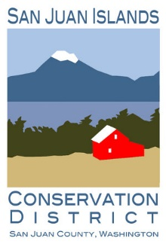
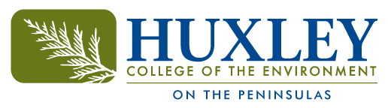

Application to the Ecological Restoration Certificate in the

San Juan Islands for 2022-2023

Please either fill out as a word document and email to kai@sjicd.org or print and submit to the San Juan Islands Conservation District at 530 Guard Street, Friday Harbor 98250. Applications will be accepted through March 31st of 2022 and the new cohort will begin on July 13th, 2022.

Name:
Email:
Phone number:
Present address:
Age:
Ethnicity:
What is your highest level of education:

1.Tell us about your employment goals moving forward:

2.Please describe relevant work experience in the field of natural resources:

3.How would the work and education in the field of restoration ecology support your goals moving forward?

4.What do you do for fun?

5. Do you have a car or a method of transportation?

6. Describe your capacity to access housing in the San Juan Islands:

7. Please provide contact information for two previous employers:

